

Physician Learners:
How to Claim MOC Part II Points
1) Complete your profile
Log into your account at UVA.cloud-cme.com. Select MyCE > Profile
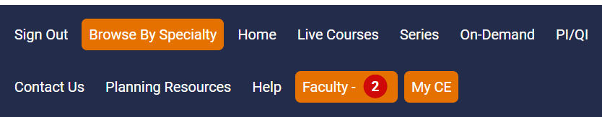
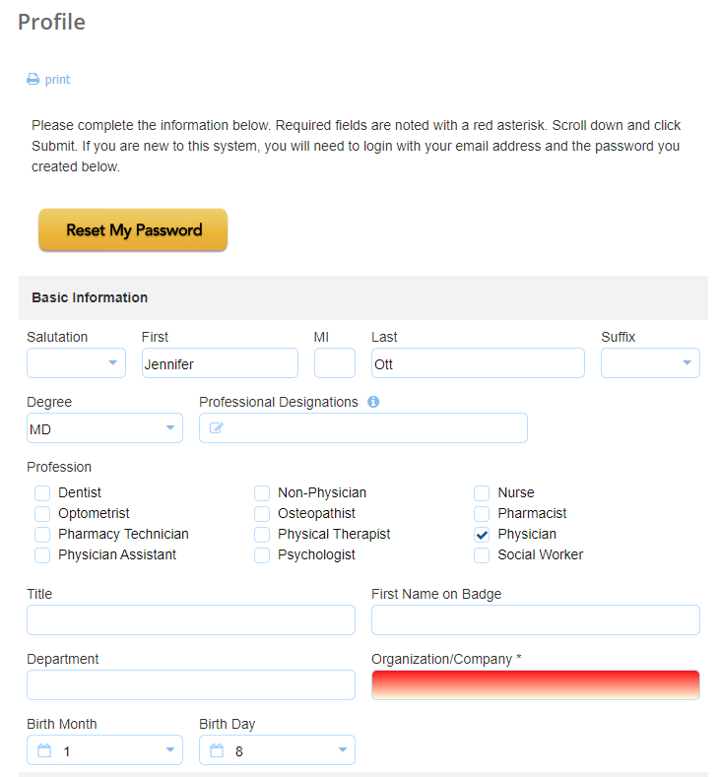

2) Complete the MOC II Section of your Profile
MOC II Credit cannot be reported to the appropriate board without the information below completed in your profile.
Required fields:
  - Degree: MD
  - Profession: Physician
  - Birth Month
  - Birth Day
  - NPI number – NPI Lookup
  - “Will you be claiming MOC points” must be checked yes
  - Specialty Board
  - Diplomate ID (use applicable board link listed below the field to look it up)
  - The last checkbox “I provide permission…certifying boards” must be checked

When all information has been entered, click the Submit button at the bottom of the screen.

3) Claim credit for sessions offering MOC Part II
- Record attendance in CloudCME within 6 days of the session via text or the website.
- Take the required evaluation in CloudCME within 6 days of the session.
  - CE Credit and MOC II points are not awarded until the evaluation is completed.

- Go to MyCE > Evaluations and Certificates.
- Click the Complete Evaluation button and submit the evaluation.
- Click the Claim MOC button. Only select boards that you are a member of.
- Click Next. If an attestation is required, you will be redirected to complete this. Otherwise, credit will be awarded, and you can download your certificate.

MOC Part II is not offered in December for end of year reporting purposes. It is reported monthly.

Get the CloudCME App!
The CloudCME® mobile app provides easy access to most CloudCME® features. After downloading the app and logging in once, you can view content, complete CE tasks, browse activity listings, and check in to activities directly from your device. Once an event is complete, you can finalize the CE process by submitting evaluation forms and claiming credit. Once you have downloaded the app, enter organization: UVA.

